SIT725 TASK 2.2P

Git repo link : <https://github.com/ChoudhariJay/SIT725.git>

Screenshots:

Part 1:

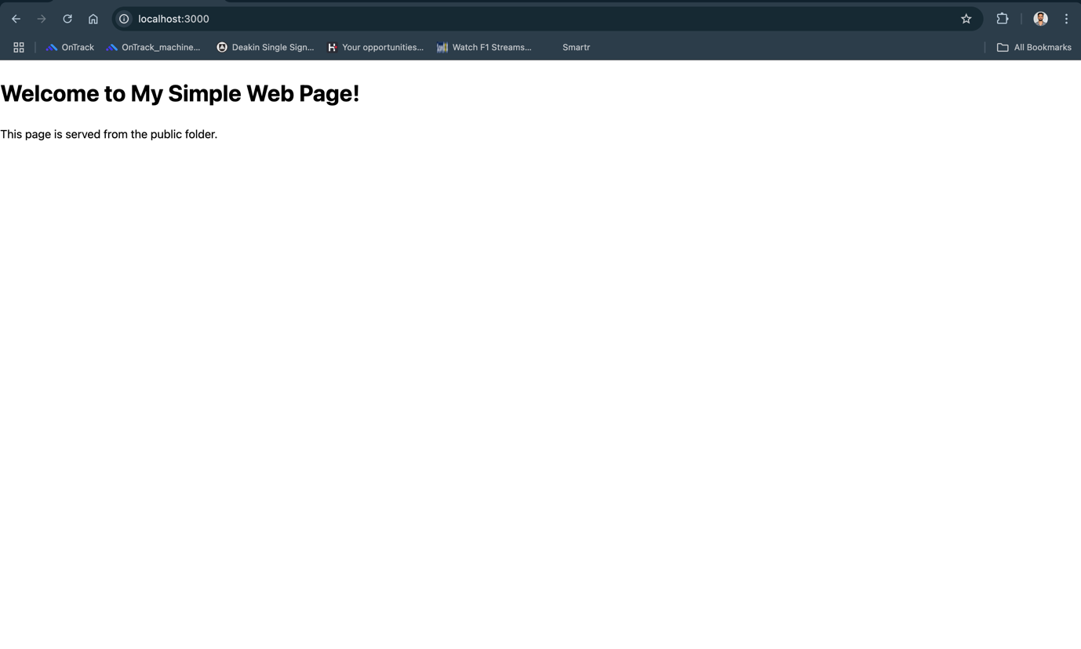

Part 2:

